# **The science behind Bell & Bone's Dental Topper: How a healthier gut will transform your pet’s mouth**

### 

### **Your pet’s dental health starts in their gut**

When we think about dog and cat dental care, we often picture toothbrushes and routine cleanings. But what if the key to a healthier mouth started deeper—within your pet’s gut? Science is uncovering the strong link between gut health and oral health, showing that a well-balanced microbiome can prevent plaque buildup, reduce gum inflammation, and even fight bad breath. That’s where our **Dental Topper** comes in—a revolutionary way to support both digestive and dental health in one simple step. Our **Dental Topper** turns your pet's favourite meal into dental food.

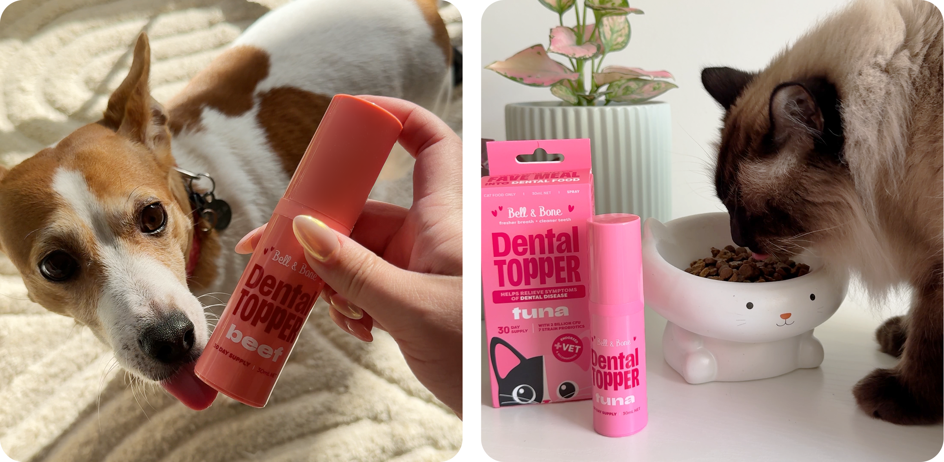

### **What are oral actives, prebiotics, probiotics, and postbiotics?**

Oral health and gut health are deeply connected, and the key to better dental care starts from within. That’s why we worked with industry experts to formulate our new **Dental Topper** with a unique blend of oral actives, prebiotics, probiotics, and postbiotics. But what do these ingredients actually do?

* **Oral actives:** These are scientifically backed compounds that target plaque and tartar while supporting gum health. They work by preventing bacterial overgrowth and protecting the enamel of your pet’s teeth.
* **Prebiotics:** These nourish the beneficial bacteria in your pet’s gut, helping to strengthen their immune system, reduce inflammation, and create a healthier balance of oral and digestive bacteria to prevent dental disease.
* **Probiotics:** These live microorganisms promote a balanced gut microbiome, which in turn supports immune function and helps control harmful oral bacteria linked to dental disease.
* **Postbiotics:** These are bioactive metabolites that reinforce gut health, modulate immune responses, and inhibit harmful bacteria associated with dental issues.

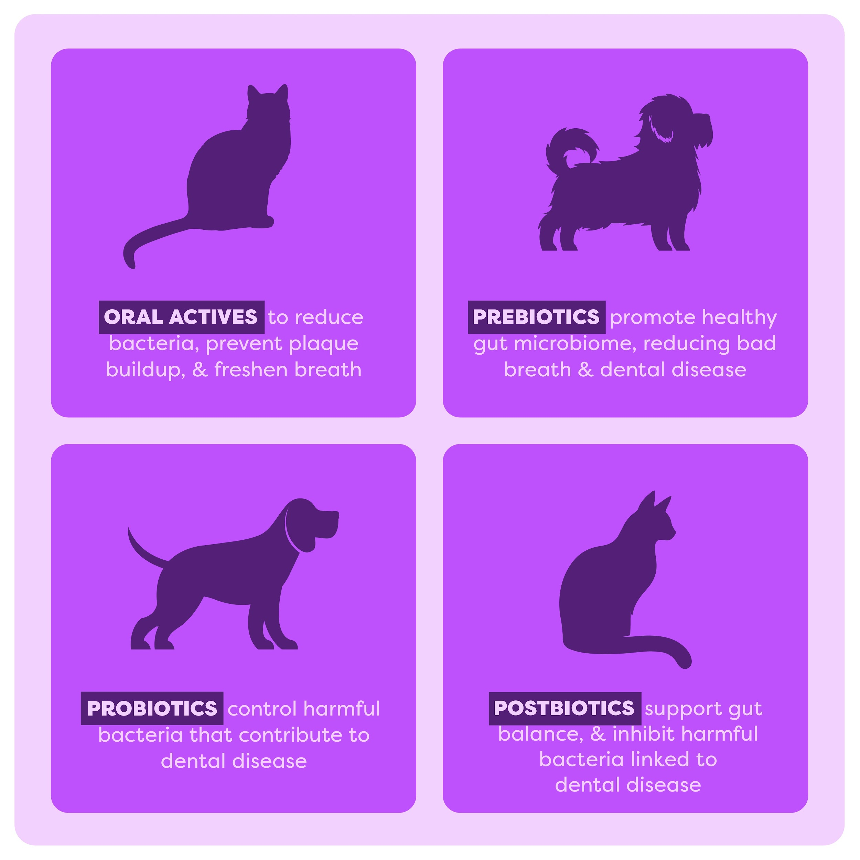

### **How does the gut impact your pet’s teeth?**

At Bell & Bone, we believe true pet health starts from within. A balanced gut microbiome plays a crucial role in maintaining oral health, and when it's disrupted, harmful bacteria can thrive—not just in the gut, but throughout your pet’s body, including their mouth. This can lead to inflammation, gum disease, and bad breath.

That’s why we created our new **DIY Dental Food**—to align with our philosophy of science-backed, natural pet care. By nurturing a healthy gut microbiome, it naturally reduces the conditions that allow plaque and tartar to form, reinforcing a strong foundation for your pet’s dental health. Because at Bell & Bone, we believe better health starts with better nutrition, and every meal should contribute to your pet’s well-being.

### **The relationship between oral actives, prebiotics, probiotics, and postbiotics**

Think of these four components as a complete dental and digestive care system:

* **Oral Actives** directly combat plaque, tartar, and bad breath at the source.
* **Prebiotics** feed good bacteria, ensuring they outcompete harmful bacteria in the gut and mouth.
* **Probiotics** restore microbial balance, reducing inflammation and improving overall health.
* **Postbiotics** provide bioactive compounds that maintain a stable, healthy microbiome.

This holistic approach means that every part of your pet’s health—inside and out—is supported with every meal.

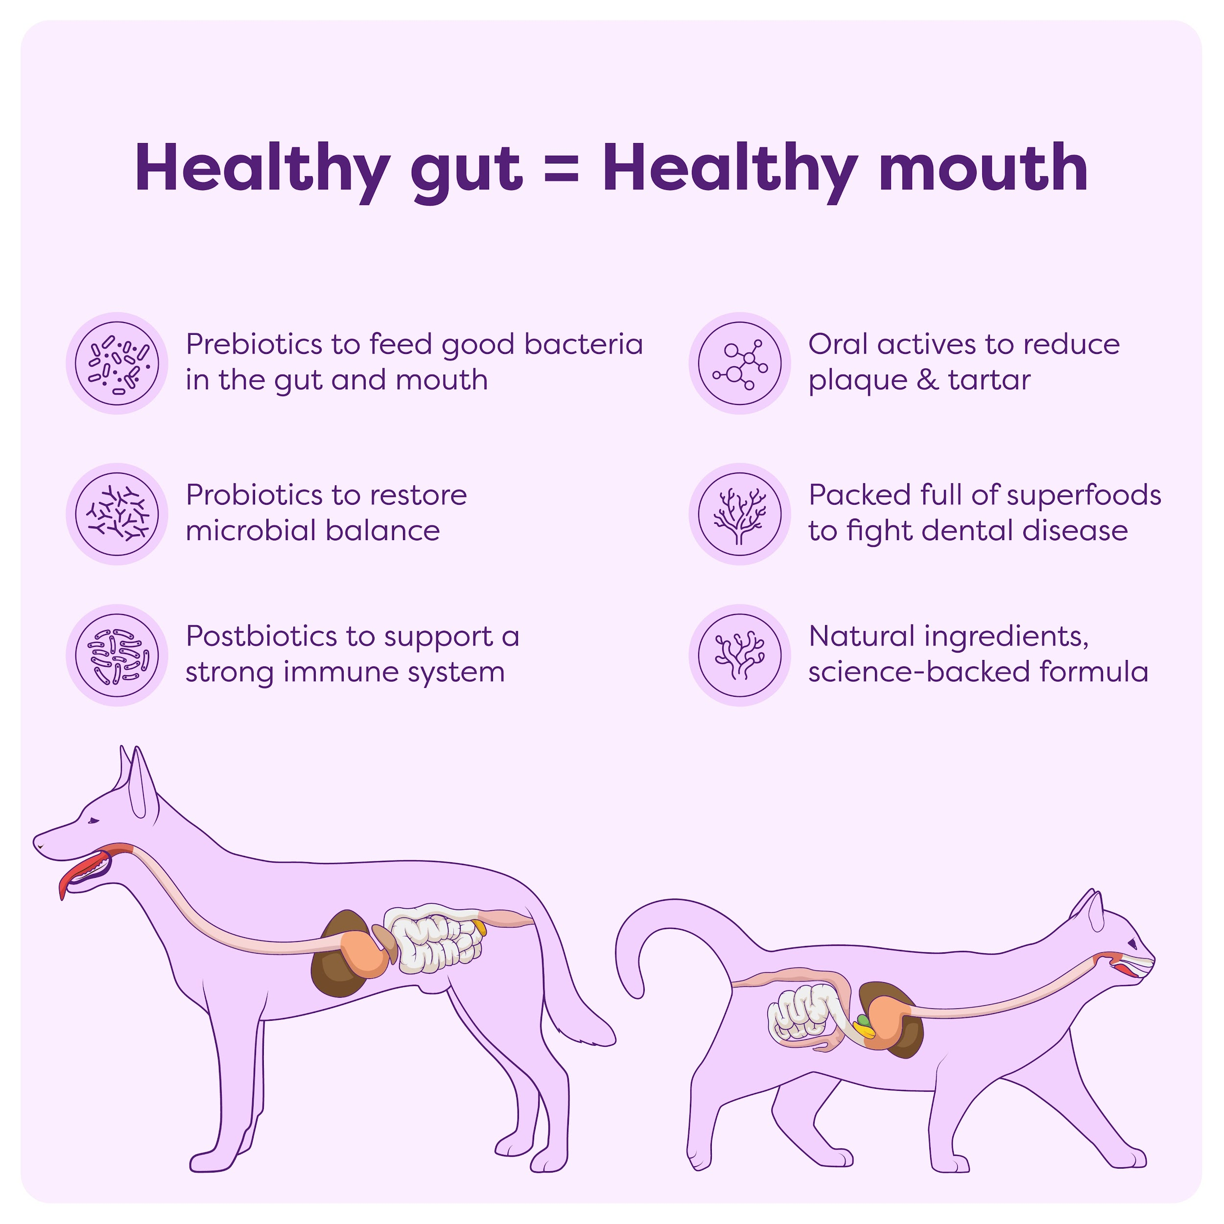

### **Ingredient spotlight: Nature’s best for oral health**

Our new **Dental Topper** is made with a powerhouse blend of natural ingredients carefully selected to support dental and digestive health. Some of the star ingredients include:

* **Ascophyllum Nodosum (Norwegian kelp):** A natural seaweed extract that fights dental issues while supporting a healthy gut. Rich in properties that improve gut bacteria balance and reduce inflammation.
* **Probiotics (Enterococcus faecium, Lactobacillus plantarum, Lactobacillus rhamnosus, Bifidobacterium lactis):** These beneficial bacteria help balance gut flora, reducing plaque buildup and supporting oral and digestive health.
* **Blueberry, Calendula, Cranberry, Green Tea & Rosemary Extracts:** Packed with antioxidants that combat inflammation and support a balanced gut microbiome.
* **Sodium Alginate:** A seaweed-derived ingredient that helps our new DIY Dental Food adhere to teeth and gums for better effectiveness, while also acting as a prebiotic to nourish good gut bacteria.
* **Sodium Tripolyphosphate (for dogs):** Helps prevent plaque buildup by reducing calcium deposits in the mouth, making it harder for tartar to form.
* **Yucca Schidigera Extract (for cats):** Supports gut health with natural prebiotics and helps reduce stool odour.

### **Better dental health begins in their gut**

The root cause of dog and cat dental disease often lies in an unbalanced gut microbiome. When harmful bacteria thrive, they release inflammatory molecules that spread throughout the body, creating the perfect conditions for gum disease, bad breath, and plaque buildup.

Our new **Dental Topper** helps break this cycle by restoring a balanced gut and oral microbiome. By addressing the root cause—gut imbalance—it naturally supports stronger teeth, healthier gums, and fresher breath without harsh chemicals or artificial additives.

### **The future of dental health is coming…**

Gone are the days of fighting with your pet to brush their teeth or relying on outdated dental solutions. With our new product, dental care becomes effortless, effective, and backed by science. A simple daily product can make a world of difference in your pet’s oral health, starting from within.

Sign up to be the first to get your hands on this one-of-a-kind product. Better dental health for your pet is just around the corner.