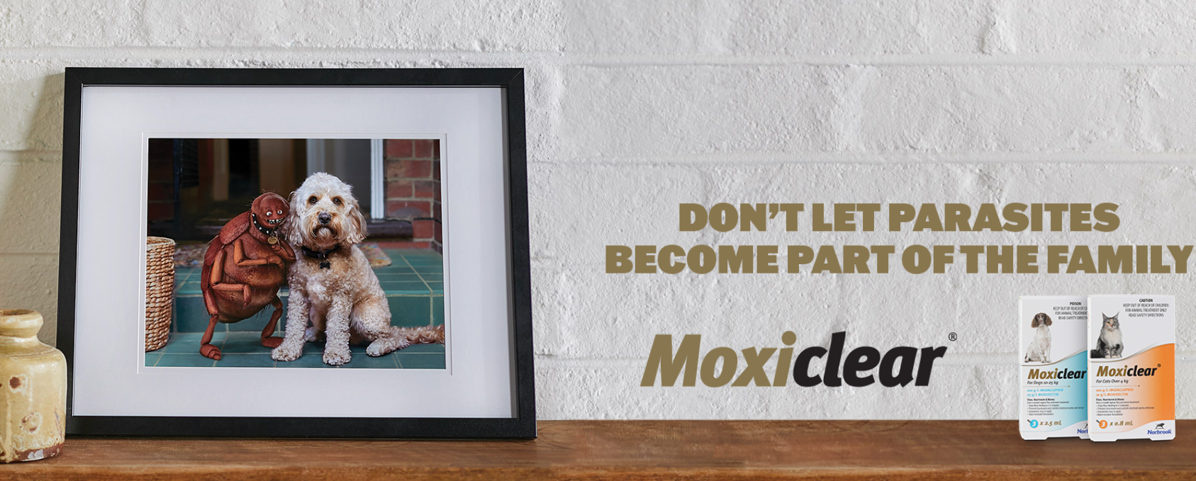

**Moxiclear: Affordable, Effective, and Trusted Parasite Protection for Pets**

Moxiclear is a monthly spot-on treatment for dogs and cats, delivering **broad-spectrum protection** against fleas, heartworms, and gastrointestinal worms. With **11 SKUs covering all sizes**, Moxiclear ensures comprehensive care for pets of all dog and cat breeds and weights.

**Why Choose Moxiclear?**

1. **Veterinarian-Approved Formula** – A trusted solution backed by extensive research.
2. **Fast-Acting & Long-Lasting** – Kills fleas in 3-5 mins and prevents reinfestation for a full month.
3. **Waterproof & Easy to Apply** – Stays effective even after bathing or swimming.
4. **Cost-Effective Alternative** – A high-quality generic option, offering pet owners affordability without compromising on protection.
5. **Safe for Multi-Pet Homes** – Suitable for both cats and dogs when used as directed.

**Limited-Time Offer: 25% Off All Products!**

Now is the perfect time to stock up on Moxiclear and boost your sales. Place an order today and take advantage of **exclusive savings on the full range!**

