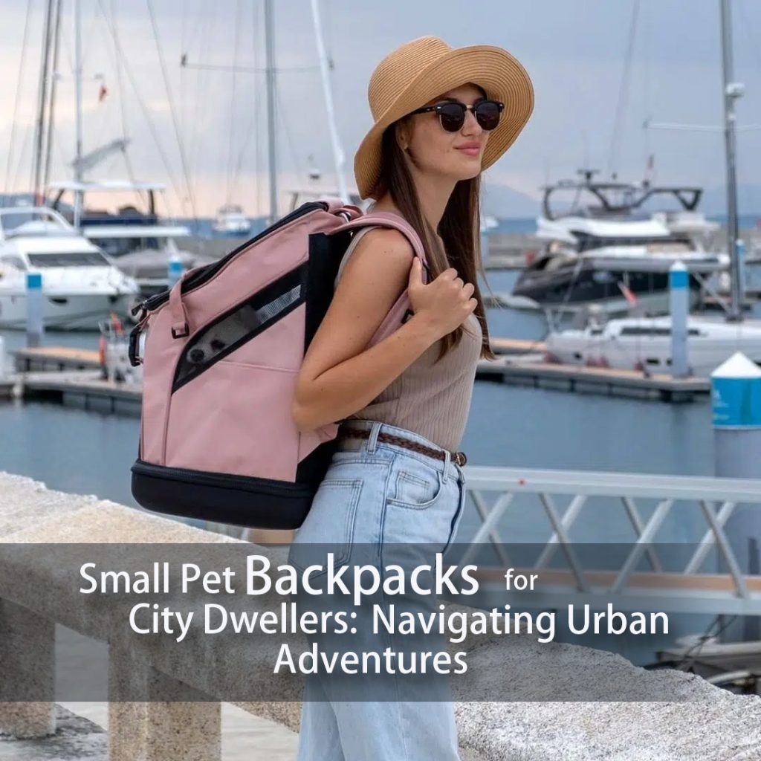

Small Pet Backpacks for City Dwellers: Navigating Urban Adventures
Hey there, fellow pet lovers and city explorers! If you’re a proud pet owner living in the heart of the concrete jungle, you know that navigating urban adventures with your furry friend can be both exciting and challenging. Whether you’ve got a pint-sized pup or a tiny tabby, we’ve got just the thing to make your city escapades a breeze – small pet backpacks!
Let’s dive into the world of these handy accessories that are sure to make your pet’s tail wag with joy.
- Adventure Awaits – Anytime, Anywhere!
- Pet Comfort and Safety First
- Tiny Paws, Big Adventures
- On-the-Go Convenience
- Bonding Time Extraordinaire
- Choosing the Perfect Backpack

Adventure Awaits – Anytime, Anywhere!
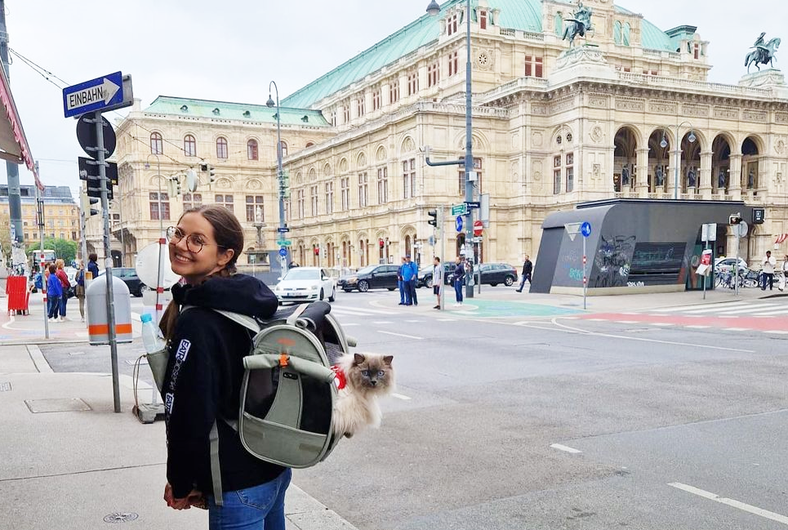
Adventure cat backpack is a perfect small cat backpacks for city dwellers!
Living in a bustling city has its perks, but it can sometimes mean limited outdoor space for our pets to stretch their legs. That’s where small pet backpacks swoop in to save the day! These ingenious contraptions allow you to take your four-legged friend on journeys that were once limited to your imagination.

Pet Comfort and Safety First
You might be wondering, “Will my furball be comfy in a backpack?” Well, fret not, dear pet parent! These small pet backpacks are designed with your pet’s comfort in mind. They come with cozy cushions, breathable mesh panels, and adjustable straps to ensure your furry buddy can enjoy the ride without feeling cramped or confined. Plus, they’re equipped with safety features like secure harnesses and sturdy zippers, giving you peace of mind as you navigate through the bustling streets.

Tiny Paws, Big Adventures
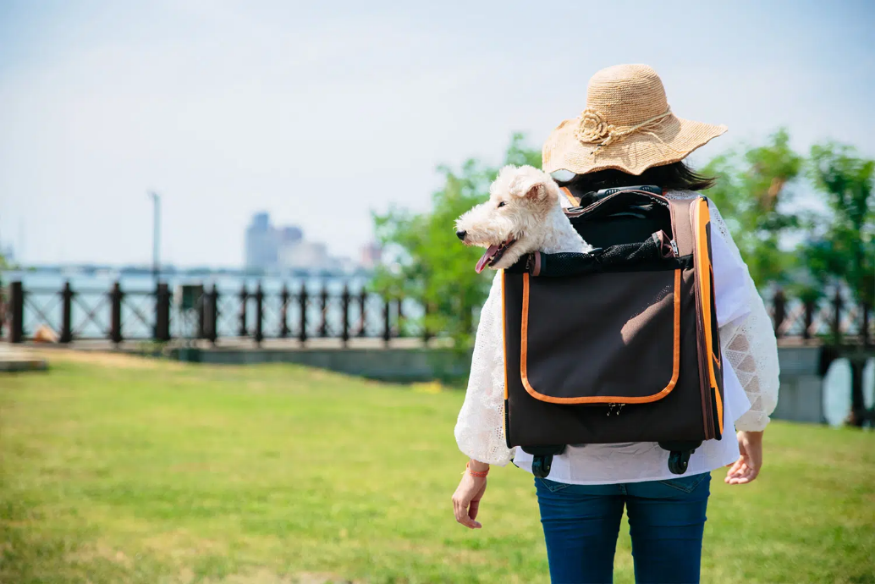
New Liso Small Pet Backpack with Transport Pet Trolley
From pet-friendly cafes to urban parks, the city is teeming with exciting places to explore. With a small pet backpack, you can introduce your companion to new sights, sounds, and smells without worrying about crowded streets or long walks. Imagine your little doggo peering out from the backpack’s window, taking in the cityscape, or your curious kitty watching the world go by – it’s like a front-row seat to a pet-friendly urban safari!

On-the-Go Convenience
Pet backpacks are not just comfortable for your furry friend, but they also offer you the convenience of hands-free exploration. No more juggling leashes, bags, and your pet – simply strap on the backpack, and you’re good to go. Whether you’re hopping on public transportation, strolling through farmers’ markets, or even embarking on a spontaneous shopping spree, your pet can tag along without causing a fuss.

Bonding Time Extraordinaire

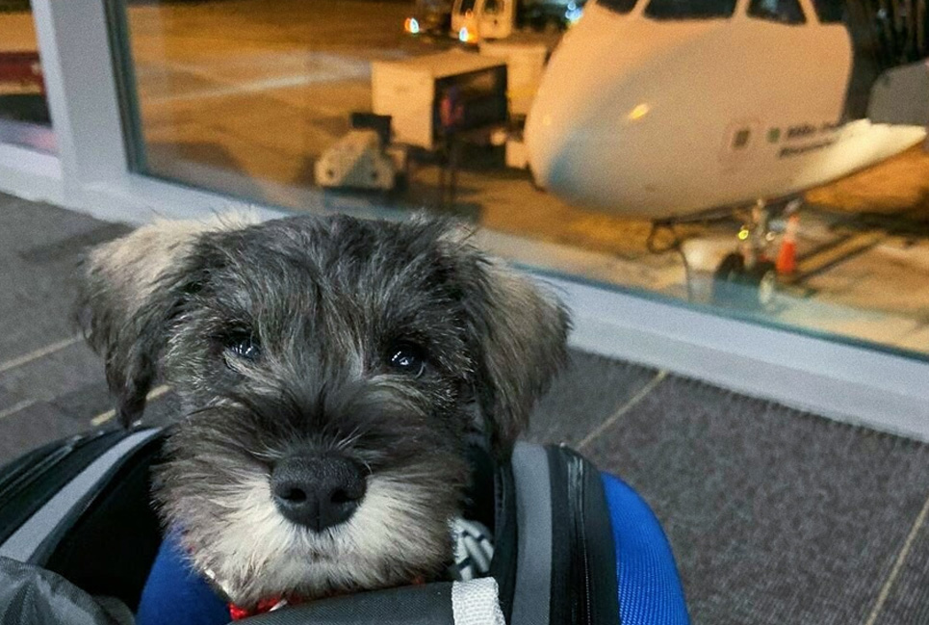
EVA Small Dog Backpack-Stroller Combo at the Airport
Living in a city can sometimes mean busy schedules and limited quality time with your pet. Using a small pet backpack provides you with the perfect opportunity to bond while you’re out and about. Your pet will love being close to you, and you’ll cherish the shared experiences of discovering new corners of your city together. It’s a win-win for both of you!

Choosing the Perfect Backpack
When it comes to selecting the perfect pet backpack, it’s essential to consider both your pet’s comfort and your convenience. Not all backpacks are created equal, so here are some handy tips to help you make the best choice:
- Size Matters: Ensure that the backpack is appropriately sized for your pet. They should be able to sit, stand, and turn comfortably inside. The Two Tier Pet Backpack is spacious for small dogs, cats and rabbit.
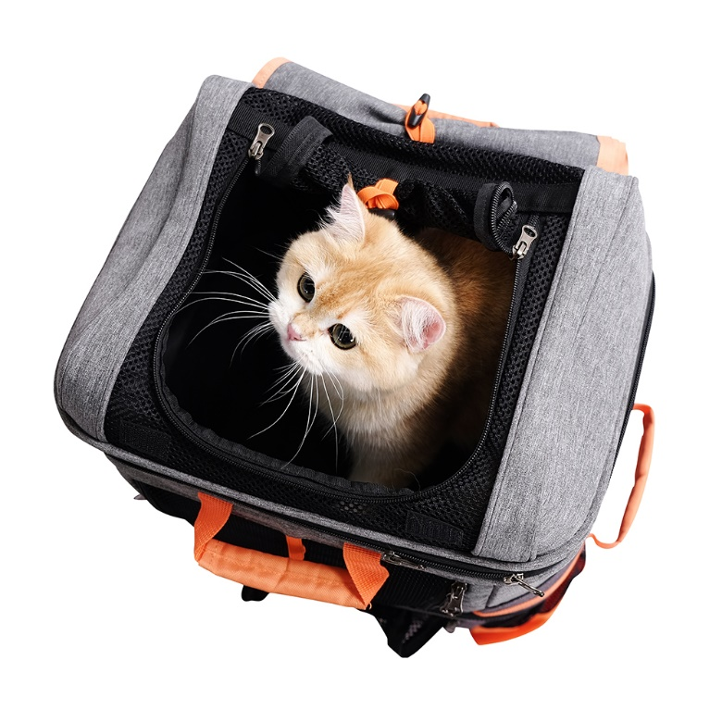

Two Tier Small Dog Backpack – double the adventure
- Ventilation is Key: Look for a backpack with mesh panels that provide proper airflow, preventing your pet from feeling stuffy during your adventures. Ibiyaya’s New Denim Fun Lightweight Pet Backpack meets this qualification as it’s equipped with multiple mesh windows to ensure your pet’s ventilation inside!
- Comfort Features: Opt for a backpack with padded interiors and adjustable straps. Your pet’s comfort during the journey is of utmost importance.
- Safety First: Check for secure closures, such as sturdy zippers and clips, to prevent your pet from accidentally escaping.
- Weight Distribution: Look for a backpack with well-padded shoulder straps and a supportive chest or waist strap to evenly distribute the weight, like Ibiyaya’s Two-Tier Pet Backpack.
- Ease of Use: Consider how easy it is to put your pet in and take them out of the backpack. The process should be stress-free for both of you.
- Pet’s Personality: Pay attention to your pet’s temperament. Some pets may enjoy a backpack with a transparent window to observe their surroundings, while others might prefer a more secluded space.
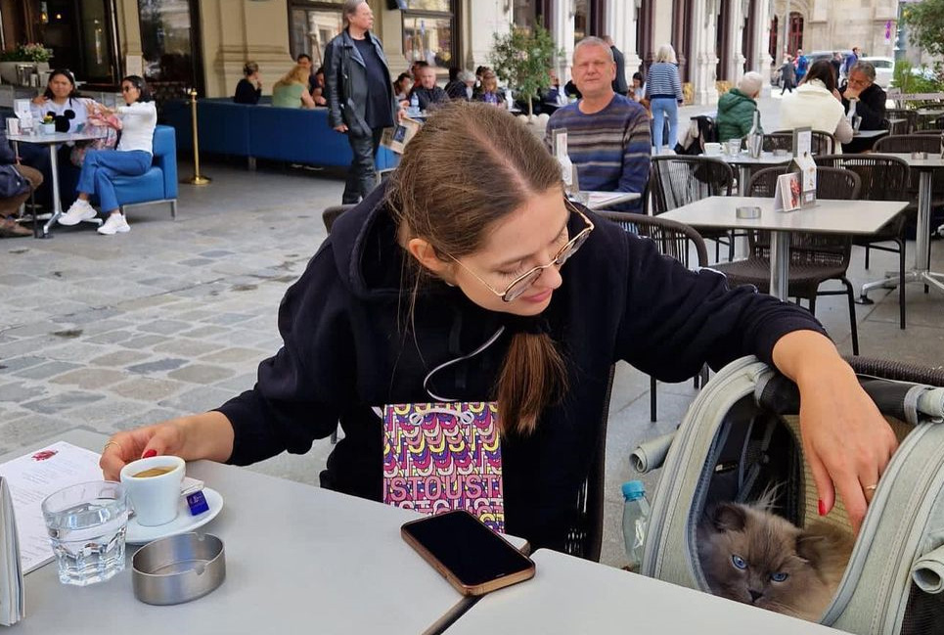

Embrace Urban Adventures with Your Furball
In a world where city living and pet companionship beautifully collide, small pet backpacks offer a unique way to navigate urban adventures. From brunch outings to art gallery tours, your furry friend can now be your sidekick in every urban endeavor. So, don’t hesitate – gear up with a pet backpack and let the good times roll as you and your beloved pet make unforgettable memories in the heart of the city!

