
WHY DOES ENDURO USE KANGAROO?
At Enduro, we’ve always believed that what you put into your dog’s bowl should have a clear purpose. From the very beginning feeding hardworking dogs across Australia’s farms, stations and backyards - we choose ingredients that deliver real performance, not just fill a bag.
That’s exactly why kangaroo has been part of the Enduro story since day one.

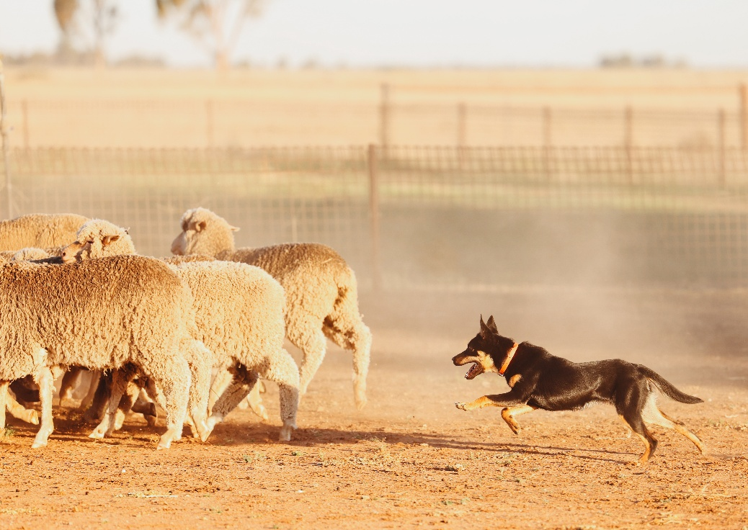
A Naturally Lean Protein for Strength and Endurance
Kangaroo meat is one of the leanest and most nutrient-dense red meats available, making it an exceptional choice for dogs. It is naturally low in fat, which supports healthy weight management while helping maintain lean muscle mass and strength.
For Enduro, this matters. Whether it’s a working dog covering kilometres in a day or a family pet with a big appetite for life, lean, high-quality protein helps fuel consistent energy without unnecessary bulk. It’s clean, efficient nutrition - exactly what Australian dogs need.

Built for Digestibility and Real Energy
As a highly digestible protein source, kangaroo is gentle on the digestive system, ensuring efficient nutrient absorption and energy utilisation.
This has always been a key driver behind Enduro formulations. Dogs that perform—whether on the job or at play, need food that works with their body, not against it. By using kangaroo, we help ensure every meal delivers usable energy that supports stamina, recovery and day-to-day vitality.

Essential Minerals for Whole-Body Health
Rich in vital minerals like iron and zinc, kangaroo meat contributes to optimal red blood cell production, a strong immune system, and healthy skin and coat.
- Iron helps transport oxygen throughout the body, boosting stamina and endurance
- Zinc supports wound healing, metabolism, and skin integrity
These are not “nice-to-haves”, they’re essentials. And they’re part of the reason Enduro has always backed kangaroo as a core protein. It supports dogs from the inside out, helping them stay resilient, active and ready for whatever the day brings.

Complete Protein for Muscle, Repair and Performance
Kangaroo provides all the essential amino acids dogs need for tissue repair, muscle development and sustained energy.
From young, growing puppies to active adult dogs, these building blocks are critical. Enduro’s commitment has always been to deliver complete, balanced nutrition - fuel that supports both performance and everyday wellbeing.

Omega Fatty Acids for Coat, Joints and Vitality
Naturally abundant in Omega 3, 6 and 9 fatty acids, kangaroo meat supports:
- Joint flexibility and mobility
- Cognitive function
- A healthy, shiny coat
- Reduced inflammation and heart health
For Enduro, this aligns perfectly with our philosophy: Nutrition should not only sustain dogs, it should help them thrive. These natural benefits are a big part of what gives Enduro-fed dogs their condition, shine and energy.

Australian, Sustainable, and True to Our Roots
Sourced from free-range kangaroos that live in the wild, this meat is naturally hormone-free and environmentally sustainable.
That’s important to us. Enduro was born in Australia, built around Australian conditions, and designed for Australian dogs. Using kangaroo isn’t just a nutritional decision, it’s a reflection of who we are.
It’s local. It’s natural. And it makes sense.

Why Enduro Has Always Chosen Kangaroo
From the beginning, Enduro has been about feeding dogs that work hard, play hard, and need nutrition that keeps up. Kangaroo delivers on every level - lean protein, essential nutrients, digestibility, and sustainability.
That’s why it’s not just an ingredient in our products.
It’s part of our foundation.
Because when the demands are real, the nutrition needs to be too.
