# Gut Health Essentials: Probiotics, Postbiotics & Kakadu Plum for Pets

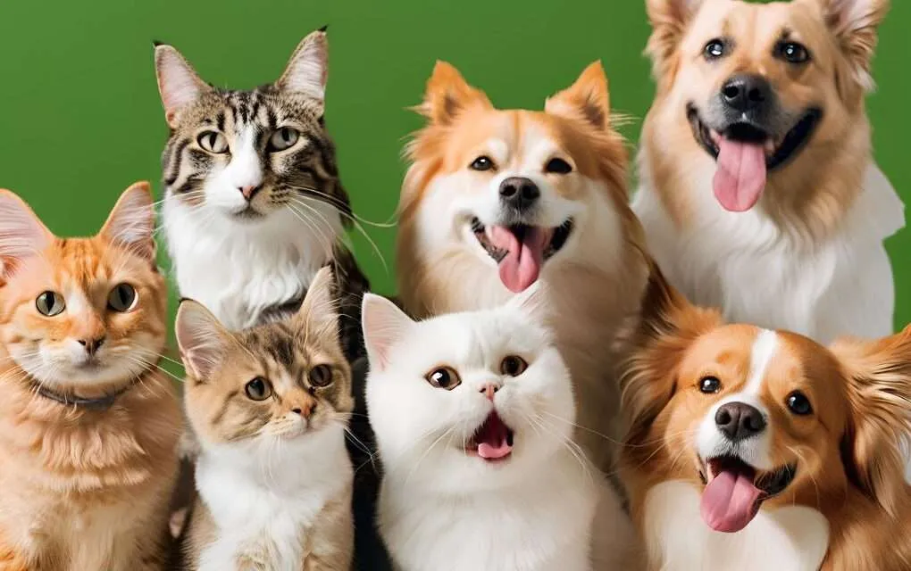

Many people might have heard the comparison of a body to a car. A body needs nutrients to thrive like a car needs petrol to run. A healthy gut is the basis of the body taking good nutrients. Maintaining good gut health is essential for pets’ overall well-being. A healthy gut supports digestion, immune function, and even mental health in pets. To achieve the best digestive health, ingredients like prebiotics, probiotics and postbiotics can make a difference. These powerful elements help to balance your pet’s gut, ensuring a healthier and happier life.

## Kakadu Plum:

Researchers in the animal nutrition field as well as business have been interested in prebiotics. Prebiotics are indigestible food components that help the colon's beneficial bacteria grow and/or proliferate. This process is helpful to the host. (Kumar & Sharma, 2024). Kakadu Plum, a small fruit native to Australia, is a superfood powerhouse for both humans and pets. It belongs to the group of prebiotics. Kakadu plum and its pectic oligosaccharide extract were studied to test their prebiotic effect. It is packed with antioxidants, particularly vitamin C, and supports the function of probiotics and postbiotics, making them even more effective. By incorporating Kakadu Plum into your pet’s diet, you enhance the ability of probiotics and postbiotics to maintain gut health and overall vitality.

## Postbiotics:

For many years, livestock have benefited from using probiotics, prebiotics, and synbiotics as growth boosters and preventative measures against various diseases (Sharma et al., 2020). Postbiotics have been classified as promising alternatives to antimicrobials due to their multiple benefits on livestock health and performance. They are regarded as immune-stimulators, anti-inflammatory, anti-oxidants, anti-microbial, as well as growth promoters (Sharma et al., 2020). Probiotics produce helpful byproducts called postbiotics. Enzymes, peptides, and other substances that improve gut health are some examples of popular postbiotics. They strive to support digestive health in general, frequently offering a more consistent, long-lasting effect than probiotics.

Probiotics:

Studies have demonstrated the protective effects of probiotics against diarrhea, as well as against allergic reactions to milk, liver illness, and certain types of cancer. (Goldin, 1998). Probiotics are often known as “good bacteria”. Probiotics for pets are live microorganisms that can help build pets’ healthy digestive systems. Probiotics aid in breaking down food, absorbing nutrients, and maintaining a balanced digestive environment. They’re especially beneficial for pets with sensitive stomachs or those recovering from illness, providing essential support for digestive health.

Overall, it has been demonstrated that many of the probiotics and prebiotics studied in dogs and cats improve immune system and gastrointestinal function. Some of these supplements have also been proven to lower potentially harmful bacterial species in the large intestine without having a negative impact on nutrient digestibility (Lin et al., 2023).

## Talentail:

Talentail is a pet food brand that focuses on enhancing pet gut health. We prioritize your pet’s health by creating the ultimate premium pet food formulated with gut-boosting ingredients like postbiotics, and prebiotics including Kakadu Plum. As an Australian brand, incorporating Kakadu Plum in pet food formulas makes it unique on the market. Kakadu plum, as mentioned before, is high in antioxidants and very beneficial to pets’ overall health. Our range of products, including dog kibbles and premium cat food, is designed to support digestive health and overall wellness. Talentail’s carefully crafted recipes provide a balance of nutrition, ensuring your pet thrives from the inside out.

To sum up, enhancing your pets’ overall health requires us to enhance the pets’ gut health. To achieve that, incorporating powerful ingredients such as prebiotics and postbiotics can help a lot. The powerful ingredients also support the immune system and improve nutrient absorption. Talentail is the leading pet food brand in this, so explore Talentail’s premium pet food products to give your pet the gut health boost they deserve now.

**Give Your Pet the Best with Talentail!**

Ready to improve the intestinal health of your pet? Explore Talentail's carefully crafted recipes to see the difference that better nutrition can make for the general health and digestive health of your pet. Start with their gut; your pet deserves nothing less.

**Stay Connected: Follow us on Social Media**

Following Talentail on social media will keep you informed about the newest developments in pet nutrition, gut health advice, and exclusive deals. Come interact with like-minded pet owners who are committed to the happiness and well-being of their animal companions!

## Frequently Asked Questions:

**What are probiotics, and why are they important for my pet?**

Probiotics are good bacteria that help keep your pet’s digestive system healthy. They break down food, aid nutrient absorption, and maintain a balanced gut. Pets with sensitive stomachs or recovering from illness can benefit a lot from probiotics.

**How do postbiotics differ from probiotics?**

Postbiotics are the by-products of probiotics. They don’t need to be alive like probiotics but still support gut health and help maintain long-term digestive stability.

**What benefits does Kakadu Plum offer for pet gut health?**

Kakadu Plum is packed with antioxidants. It boosts the effectiveness of probiotics and postbiotics, improving digestion and supporting overall gut health in your pet.

**Can I give my pet both probiotics and postbiotics?**

Absolutely! Probiotics and postbiotics work well together to keep your pet’s gut in top shape.

**How can I incorporate Kakadu Plum into my pet's diet?**

Choose high-quality pet foods that include Kakadu Plum, like those from Talentail, which are made to enhance gut health and overall wellness.

**Reference:**

Almutairi, B., Turner, M. S., Fletcher, M. T., & Sultanbawa, Y. (2023). The impact of Kakadu Plum (Terminalia ferdinandiana) fruit powder and its pectic oligosaccharides on the growth, survival and antimicrobial activity of probiotic bacteria in milk. *Food Bioscience*, *56*, 103445.

Goldin, B. R. (1998). Health benefits of probiotics. *British Journal of Nutrition*, 80(S2), S203-S207.

Grześkowiak, Ł., Endo, A., Beasley, S., & Salminen, S. (2015). Microbiota and probiotics in canine and feline welfare. *Anaerobe*, *34*, 14-23.

Kumar, R., & Sharma, A. (2024). Prebiotic-driven gut microbiota dynamics: Enhancing canine health via pet food formulation. *International Journal of Bio-resource and Stress Management*, *15*(Jun, 6), 01-15.

Lin, C. Y., Alexander, C., Vester Boler, B. M., Fahey Jr, G. C., & Swanson, K. S. (2023). Probiotics and Prebiotics: Application to Pets. In *Direct-Fed Microbials and Prebiotics for Animals: Science and Mechanisms of Action* (pp. 167-227). Cham: Springer International Publishing.

Sharma, R. K., Chauhan, K., Pathak, A. K., & Khan, N. (2020). Postbiotics for animal health and performance. *Intas Polivet*, *21*(2), 288-294.

Swanson, K. S., & Fahey Jr, G. C. (2006). Prebiotic impacts on companion animals. *Prebiotics: development & application*, 213-236.

Van Loo, J., & Vancraeynest, D. (2008). Prebiotics and animal nutrition. In *Handbook of prebiotics* (pp. 439-454). CRC Press.

Yang, Q., & Wu, Z. (2023). Gut Probiotics and Health of Dogs and Cats: Benefits, Applications, and Underlying Mechanisms. *Microorganisms*, *11*(10), 2452.