Why Talentail is the Key to Your Pet’s Healthy Life


Introduction
Nowadays, pet owners are becoming increasingly aware of the importance of high-quality nutrition for their furry companions. The foundation of a healthy life for pets starts with premium pet food. Choosing the right food can significantly impact your pet’s overall well-being and longevity. So many options are available on the market but how to choose the right one for your pet? Talentail stands out as a premium choice because of their focus on pet gut health, the unique incorporation of Kakadu plum, the innovative method of low-temperature baking food processing, and so on. In this blog, we will explain why Talentail is crucial for your pet’s healthy life and how it can contribute to their long-term vitality.

The Nutritional Benefits of Choosing Talentail

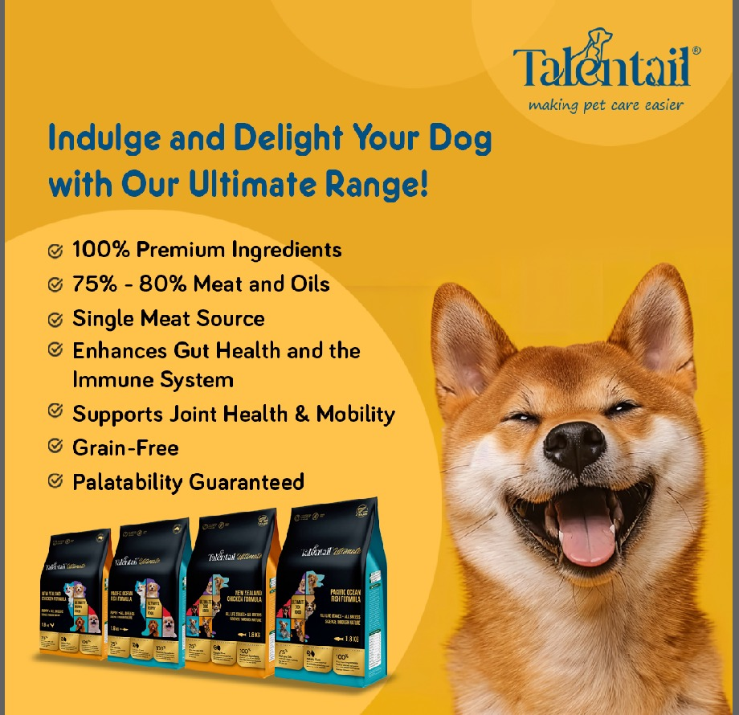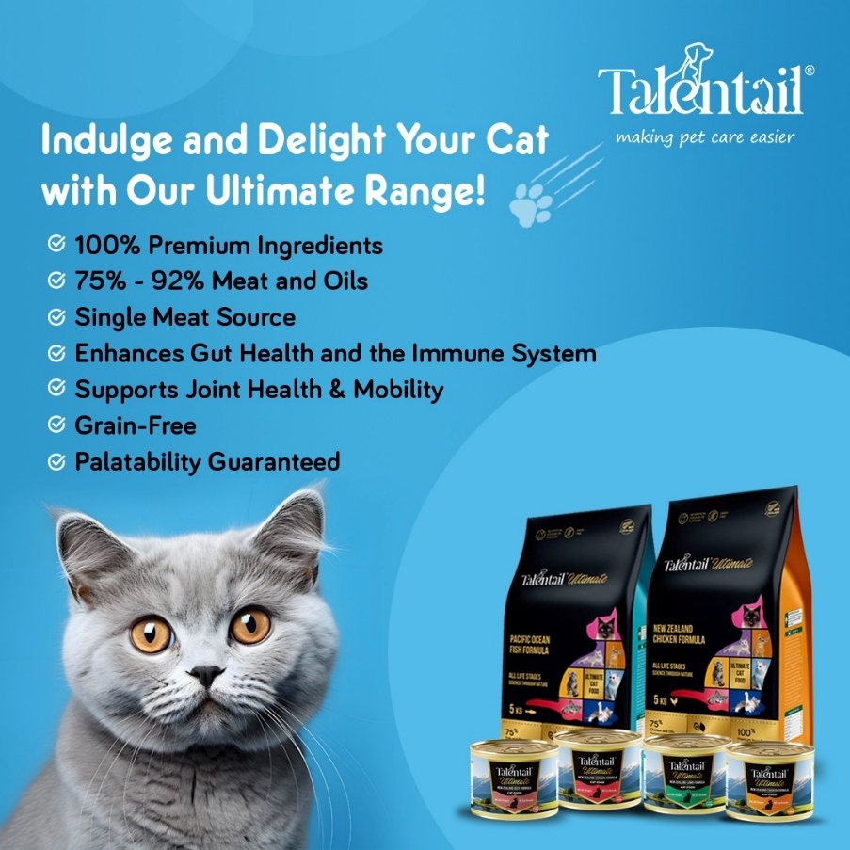

Choosing Talentail can have a lot of nutritional benefits. First of all, it is a complete and balanced diet for all life stage pets including pregnant and little ones. The ratio of the nutrients are just carefully formulated to fit all. Secondly, the addition of a lot of beneficial ingredients will help our pet maintain a healthy lifestyle. One of the examples of this is green lip muscle, which will be mentioned in the next paragraph as well. It is a great source of glucosamine. Last but not least, the innovative incorporation of Kakadu plum, the unique Australian native ingredient. It is a great prebiotic and full of antioxidants which helps to prevent a lot of chronic disease for pets.

Save on Supplements
Another one of the significant advantages of choosing Talentail pet food is that you can save on additional supplements. To meet their pet's nutritional demands, many pet owners end up buying a lot of supplements, which can quickly mount up in price. With Talentail, all the essential nutrients are included in one complete meal.
This means you can save money while ensuring your pet receives a comprehensive nutrient profile. For example, instead of buying omega-3 supplements, Talentail recipe incorporates fish oil and green-lipped mussels directly into the food. This also suits the Talentail motto - making pet care easier.

Fewer Vet Visits and a Healthier Pet
A balanced, premium diet like Talentail can lead to a healthier pet with fewer health issues. Pet owners will benefit monetarily and mentally from fewer veterinary appointments as a result of this. When pets receive proper nutrition from a young age, they are less likely to develop chronic health conditions that often require veterinary intervention.
Investing in a healthy diet upfront can save you both time and money in the long run. The right nutrition plays an important role in preventing common issues like obesity, skin irritations, and joint problems. By feeding your pet Talentail, you’re taking proactive steps toward long-term pet health.

Supporting Joint and Skin Health with Marine Collagen
One ingredient in Talentail recipe stands out. It is called the marine collagen. It offers remarkable benefits for pets. It benefits joint health and mobility as well as promotes skin wellness. As pets age, they often face joint concerns, making it crucial to provide them with food that supports their joints effectively. You can make sure your pet gets the help they require for healthy joints and vibrant skin by selecting Talentail.

Why Talentail is the Smart Choice for Pet Owners

If you are a pet lover then one of the best choices you make in your pet’s life is to provide appropriate nutrition for it. Choosing Talentail petfood to ensure your pet has a balanced nutritious diet so that your companion can have the longest natural life. Our high-quality ingredients provide lots of benefits beyond just convenience because since your pet is what you eat we decided to help you out and detail the advantages of a nutrient rich diet; better overall health, less vet visits and a longer more enjoyable life.

Conclusion: Invest in Your Pet's Health with Talentail
Choosing ultimate petfood helps to ensure your pet's optimal nutritional diet so that he or she can live the longest and healthiest possible life. Our high-quality ingredients have many benefits that go beyond convenience. You too can own a happy and healthy pet with Talentail! Make the right choice for your pet today: choose Talentail. Caring pet owners choose Talentail. You deserve the best, and your pet can be at their best when you use Talentail.

Frequently Asked Questions
- What makes Talentail a premium pet food?
Talentail uses high-quality, nutrient-rich ingredients that provide balanced nutrition.
- How does Talentail benefit my pet’s skin and coat health?
Ingredients like fish oil and marine collagen promote hydration and shine in your pet’s coat.
- Can Talentail reduce the need for pet supplements?
Yes, Talentail includes all essential nutrients, eliminating the need for additional supplements.
- How does Talentail support joint health in pets?
The inclusion of green-lipped mussel and marine collagen helps maintain joint integrity and mobility.
- Will feeding my pet Talentail help reduce vet visits?
A balanced diet can lead to fewer health issues, resulting in less frequent veterinary care.
- What are the benefits of marine collagen in pet food?
Marine collagen supports joint health and skin wellness, especially in aging pets.
- Is Talentail suitable for pets with allergies?
Talentail is formulated with high-quality ingredients, but it's always best to consult your vet if your pet has specific allergies.
- Does Talentail help improve my pet's immune system?
Yes, a balanced diet contributes to overall health, including a stronger immune system.
- Why should I choose premium pet food like Talentail?
Premium pet food ensures your pet gets the best nutrition, leading to a healthier, happier life.
- How does Talentail compare to other premium pet foods?
Talentail offers unique ingredients such as Kakadu plum that support multiple aspects of health, making it a standout choice.

