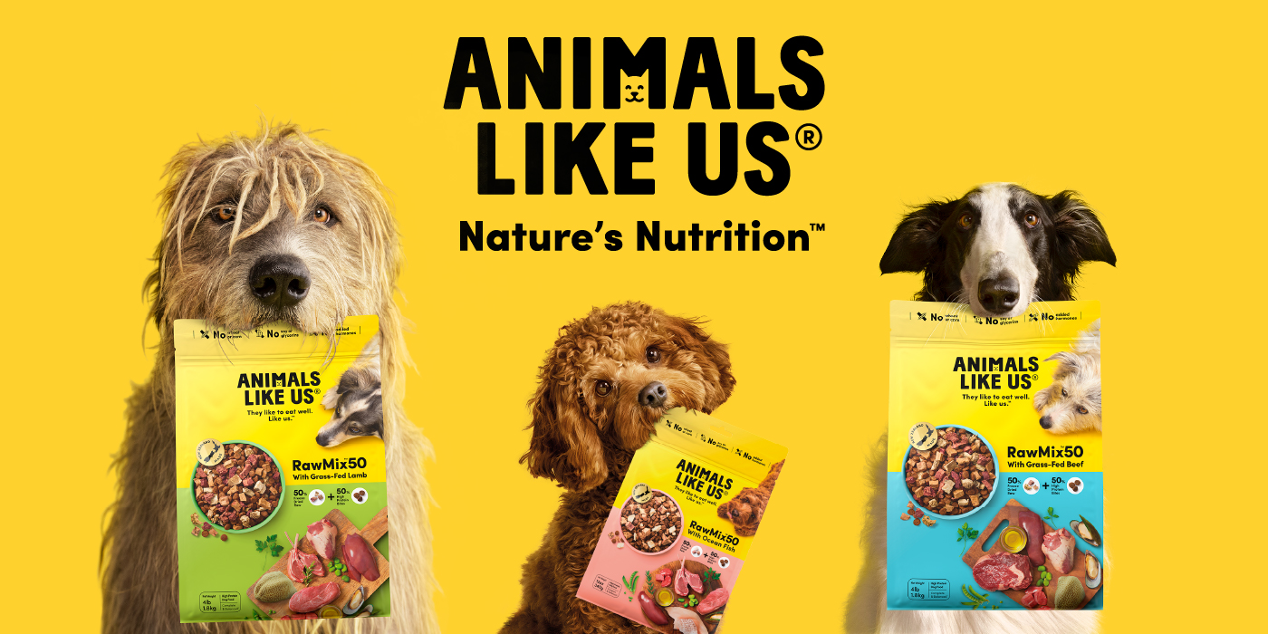
The Easy Way to Feed Dogs the Raw Nutrition They Love
Dogs may have come a long way from their wolf ancestors, but their nutritional needs haven’t changed. They thrive on a diet rich in real meat and organ meats—the most nutrient-dense superfood nature has to offer. That’s why Animals Like Us™ created a better way to feed raw, making it simple, safe, and mess-free.
A Smarter Way to Feed Raw
RawMix50™ and RawMix33™ take the hassle out of feeding raw. Unlike traditional raw diets that require preparation, storage, and food safety precautions, these premium blends combine real chunks of freeze-dried raw meat and organs with high-protein kibble. That means all the taste and benefits of raw nutrition—without the mess.
- RawMix50™: 50% real freeze-dried raw meat & organs + 50% high-protein kibble.
- RawMix33™: 33% real freeze-dried raw meat & organs + 67% high-protein kibble.
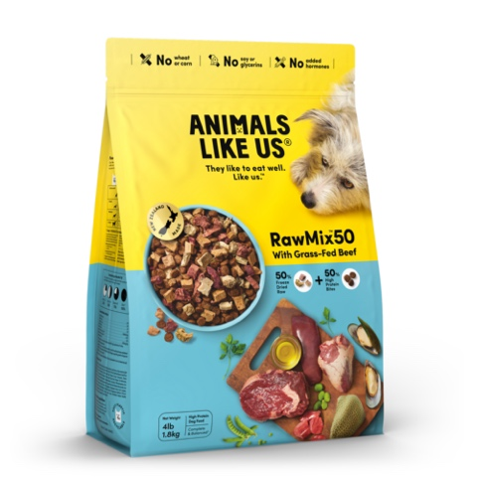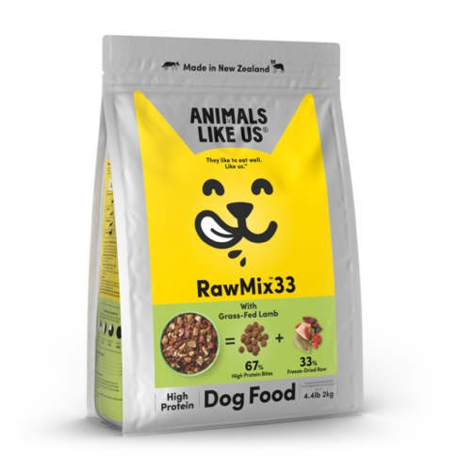

Both options deliver complete and balanced nutrition with high protein and low carbohydrates, making it easy to feed dogs what they crave.
Why Organ Meats?
Dogs instinctively love the rich, meaty taste of organ meats, and for good reason. Liver, heart, and tripe are packed with essential vitamins, minerals, and amino acids that support digestion, energy levels, and overall health. Every Animals Like Us™ meal is powered by these superfoods, ensuring dogs get the nutrients they need to thrive.
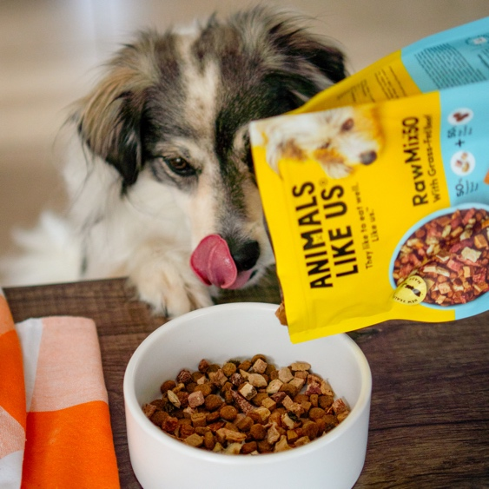
Reward with the Best Treats
For training or simply treating, Animals Like Us™ freeze-dried treats lock in the taste and nutrition dogs love. Lightweight, bite-sized, and packed with real meat goodness, they’re the perfect way to reward good behaviour—without fillers or artificial ingredients.

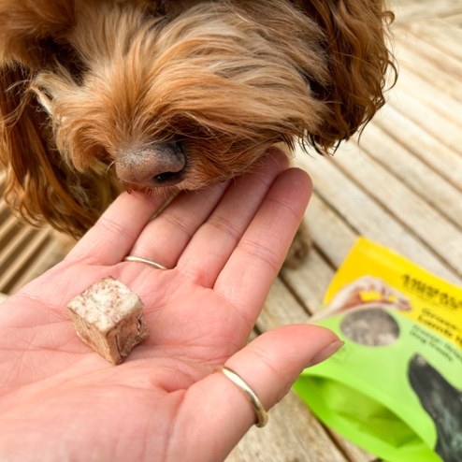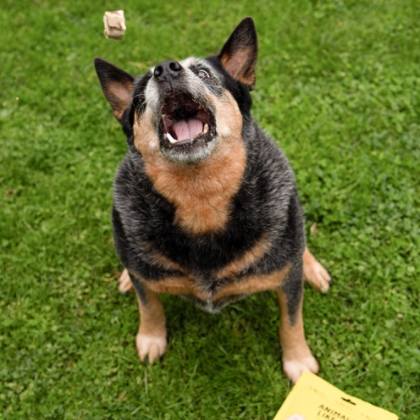

Upgrade mealtime with the easy way to feed raw. Dogs love it, and so will their owners.

