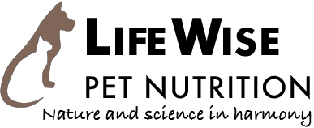

“We make sick dogs well, and well dogs better.”

LifeWise is a proudly independent family company delivering healthier outcomes to companion animals the world over. With nearly 6 decades of experience in the nutrition industry, and 37 years manufacturing performance canine diets, Bill Wiadrowski has specifically formulated the LifeWise range of diets to assist with growing and feeding the gut microbiome. These diets are a complete and balanced diet which can alleviate your well beloved pet of their health concerns due to dysbiosis of the gut microbiome.
LifeWise is 100% Australian; Australian original science, Australian pure and clean raw ingredients processed in Australia by Australians for dogs around the world.

Our philosophy:
"Our true belief is that if we are to domesticate and captive feed an animal, we have an over-arching moral and ethical obligation to provide the very best food, so the animal can be the best example of itself, and enjoy the best possible quality of life We will only ever deliver to you the very, very best".

- Healthier outcomes
A truly balanced blend of essential nutrients from quality ingredients allows the body to balance naturally, often producing amazing results for sufferers of allergies, intolerances, sensitivities or ill thrift.

- Balanced Nutrients
This perfect balance of nutrients eliminates metabolic stress, and so improves the health, disease resistance and longevity of your special companion.

- Quality & sympathetic ingredients
Whole food ingredients that are natural food sources for your pet are used exclusively in the loving preparation of this food.

- Exacting science
Over 40 years of continuous research and development in the science of perfecting food nutrient ratios to match nutrient use in the body.

- Superior bioavailability
Food that delivers precise essential nutrients in the correct ratios allows more of the food value to be used in the body with less passed as waste.

- Ethical recipes
When fed appropriately, sympathetic natural ingredients plus exacting science ethically delivers correct outcomes specific to the animal’s life stage.

